App in a Day
Hands-on Lab Step-by-Step

Contents
Importing Module 3 Completed 1
Task 1: Create a new environment 1
Task 2: Import the solution 2
Task 4: Test Machine Procurement App 6

Importing Module 3 Completed
Follow the steps below, if you did not complete Modules 1, 2 or 3 and would like to skip to Module 4

Task 1: Create a new environment
- Open a new browser tab, navigate to Power Apps admin portal select Environments and click New Environment.
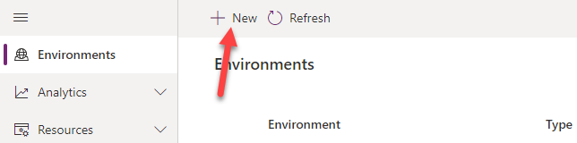
- Provide an Environment Name, select Trial for Type, select Region, select Yes, for Create a database, and click Next.
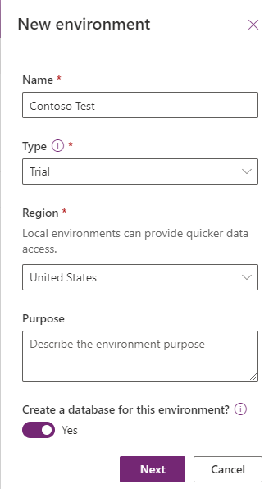
- Select Language, URL, and Currency. Choose Yes for Deploy sample apps and data and then click Save.
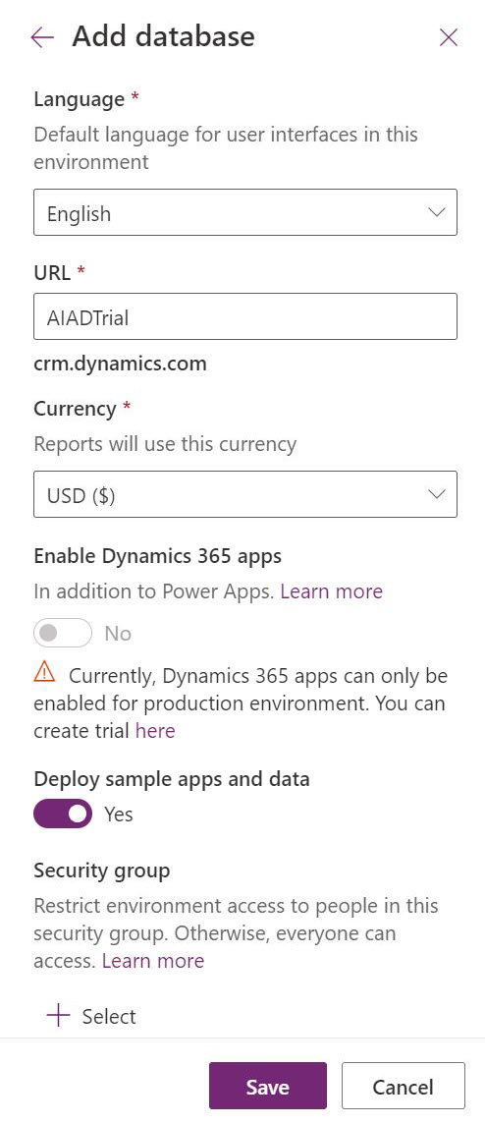
- Wait for the environment to be created.

Task 2: Import the solution
In this task, you will import the completed module 3 solution.
- Navigate to Power Apps maker portal
- Make sure you are in the Contoso Test Environment you created.
- Select Solutions.
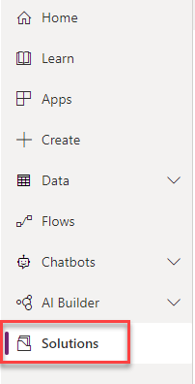
- Click Import solution.
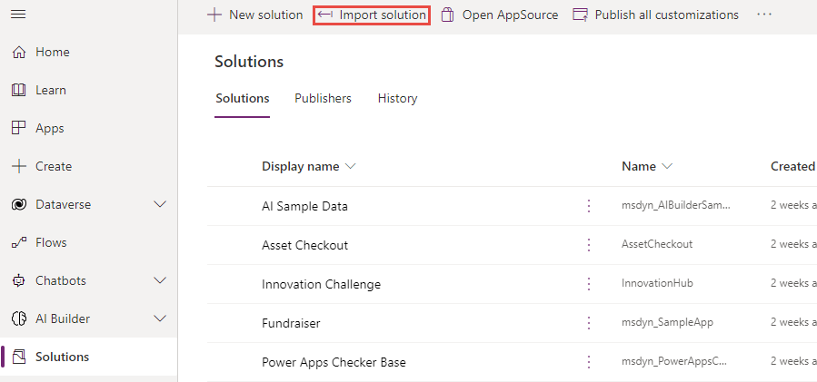
- Click Browse.
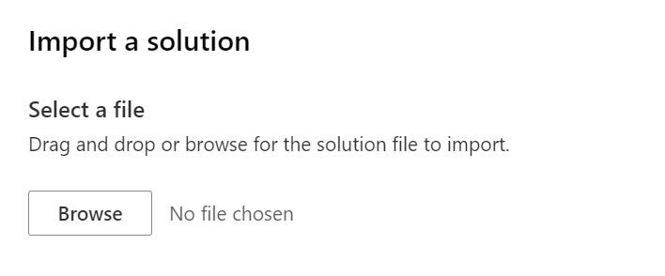
- Select the Contoso Coffee solution zip file located in Module 3 Completed folder and click Open.
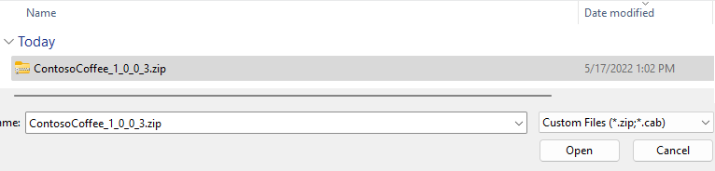
- Click Next.
- Click Import.
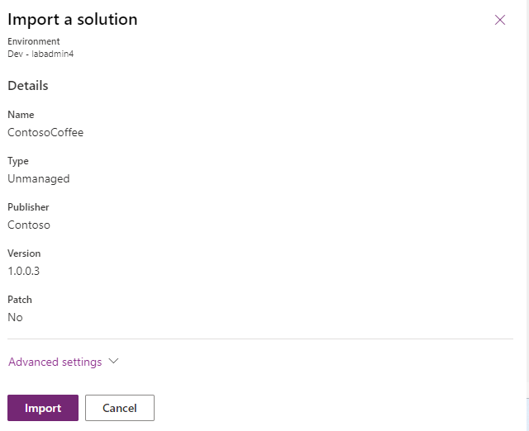
- Wait for the solution import to complete.
- Once the import is complete, Click Publish All Customizations and wait for the publishing to complete.
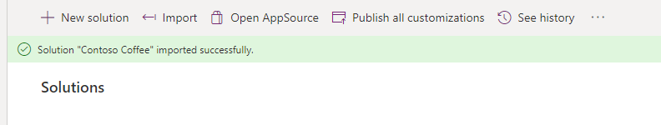
- Select Apps and launch the Machine Ordering App.
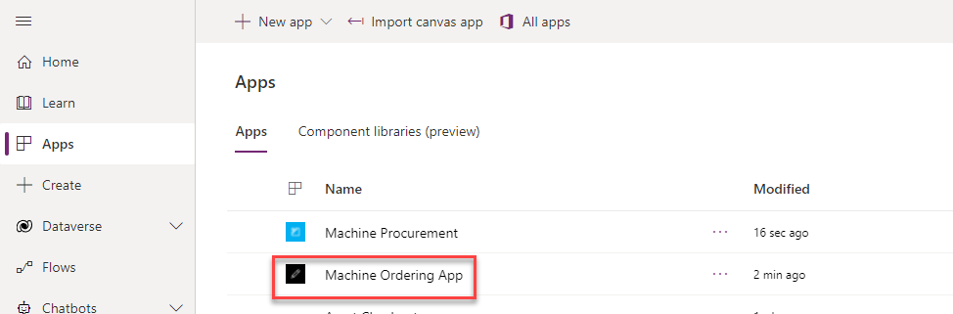
- Click Allow.
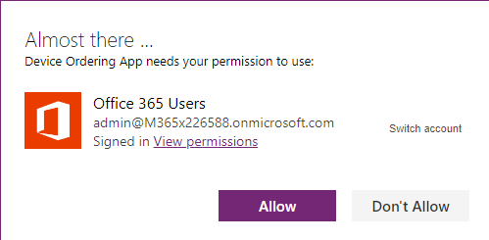
- Select few machines and click Compare.
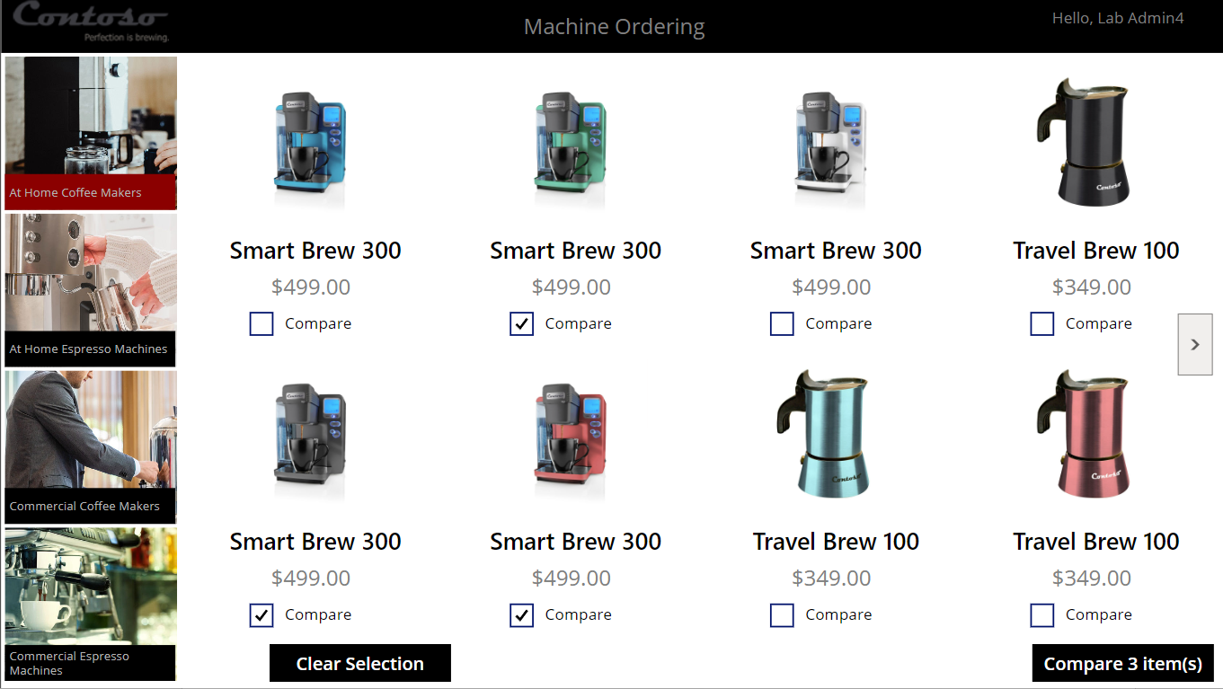
- Select one of the machines and click Submit.
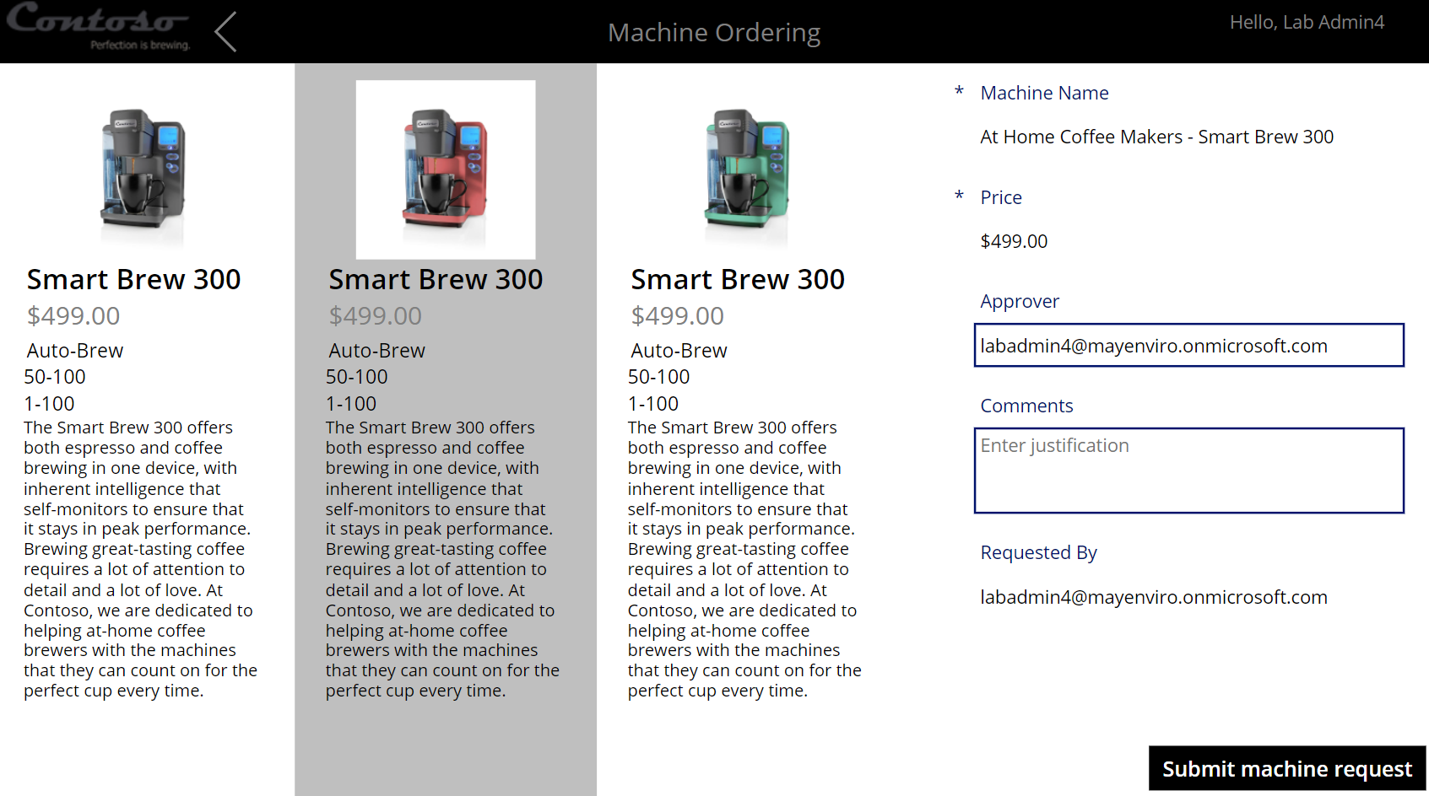
- Click OK.
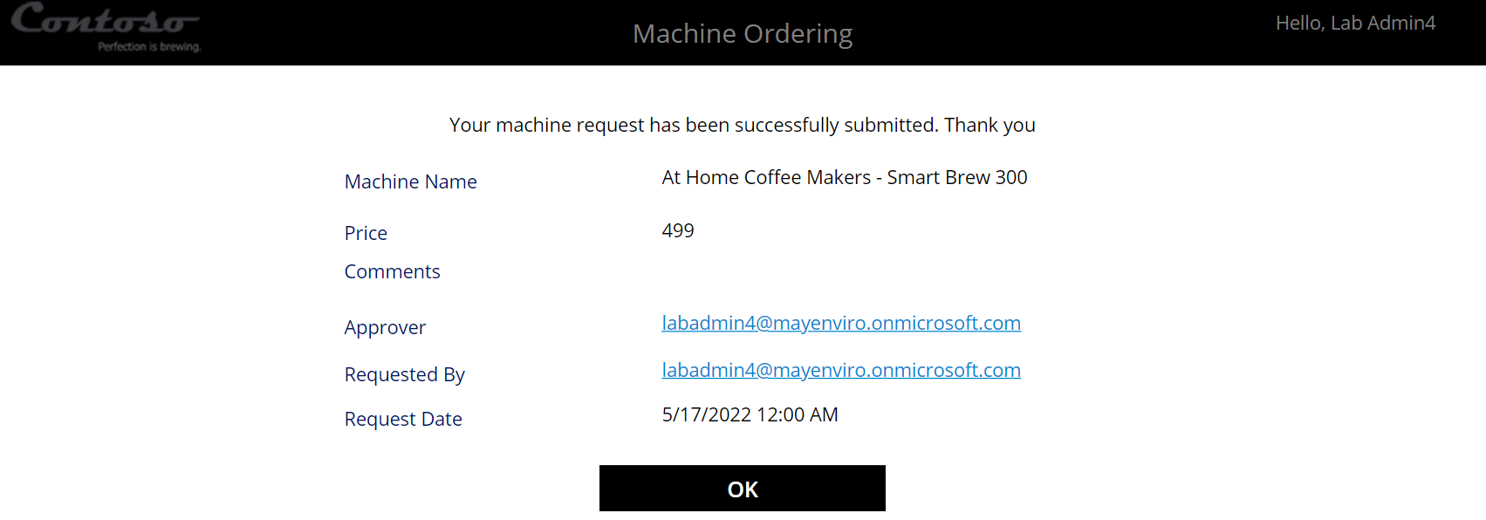
- Close the application.

Task 4: Test Machine Procurement App
- Select Apps and launch the Machine Procurement application.
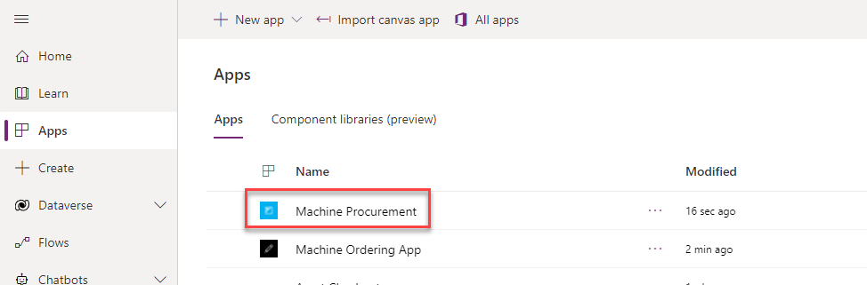
- You should see the machine you ordered on the list.
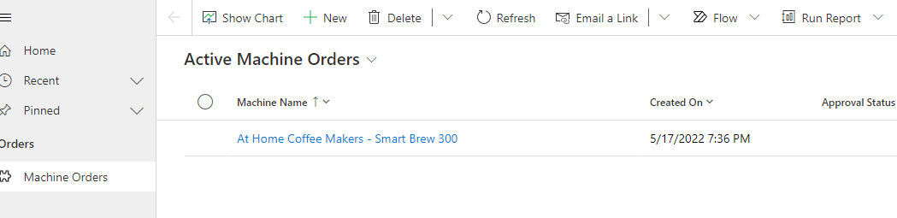
- Open the machine order record.
- You should see a business process flow.
